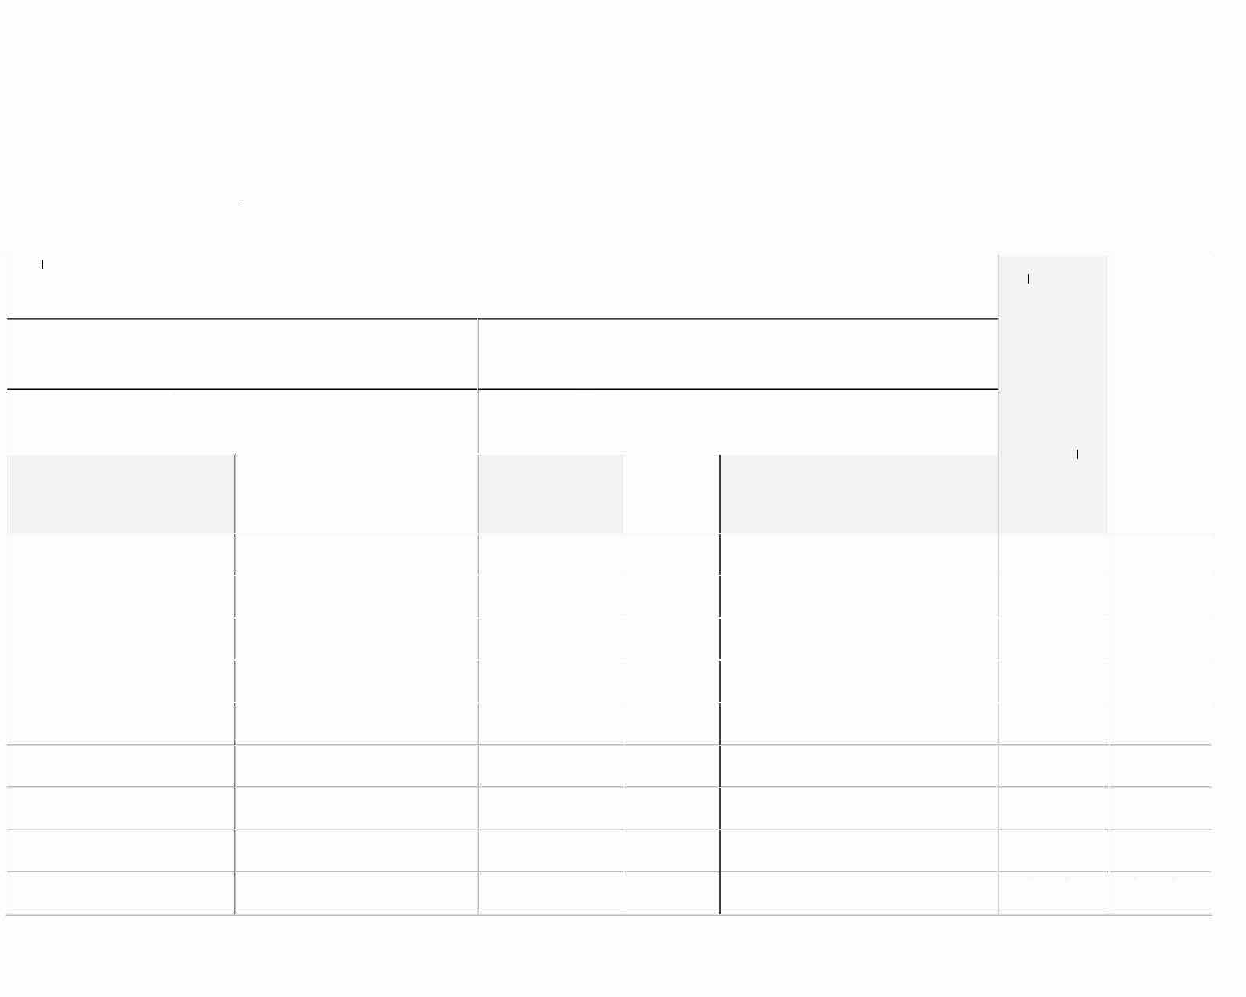
OMB Control Number 1093-0006 Expiration Date 10/31/2024

VOLUNTEER SERVICE AGREEMENT-Natural & Cultural Resources Volunteer Sign-up Form for Groups

All volunteers that participate with an organized group on an episodic volunteer project with a federal land and water management agency must be signed up on this form (unless otherwise signed up under an individual Volunteer Service Agreement, OF-301a). Volunteers under age 18 may not use this form, and must complete an individual Volunteer Service Agreement (OF 301a). This form must accompany a group Volunteer Service Agreement (OF-30la), completed by the group leader. Group leaders are responsible for ensuring every individual signed up on this form understand the duties to be performed and the terms of the project.

PRO ECT TITLE: DATE: |  |  |  |  | I understand the hea th and physical condition  requ irements for this position, and I know of no medical condition or  physical  lim itation that may adversely affect my abi ity to provide this service. | I consent to
 |  |  |  |  |  | being
 |  |  |  |  |  | photographed,
and to the
release of my
GROUP NAME: |  | AGENCY:
{Club Name Here} |  | {National Park Service – APPA, or USFS – Forest District} |  |  |  | photographic
 |  |  |  |  |  | image.
GROUP LEADER (Last, First): |  | AGREEMENT# (OF-301A box21):
VOLUNTEER NAME (Last, First) | VOLUNTEER E-MAIL ADDRESS | VOLUNTEER | MONTH & | VOLUNTEER SIGNATURE
 |  | TELEPHONE NUMBER | YEAR OF
 |  |  | BIRTH
 |  |  |  |  | Yes No | Yes | No
 |  |  |  |  | Yes No | Yes | No
 |  |  |  |  | Yes No | Yes | No
 |  |  |  |  | Yes No | Yes | No
 |  |  |  |  | Yes No | Yes | No
 |  |  |  |  | Yes No | Yes | No
 |  |  |  |  | Yes No | Yes | No
 |  |  |  |  | Yes No | Yes | No
 |  |  |  |  | Yes No | Yes | No
Volunteer Service Agreement Group Sign-up Form OF301b USDOI - USDA - USDOC - USDOD Page 1 of 2

OMB Control Number 1093-0006 Expiration Date 10/31/2024

VOLUNTEER NAME (Last, First) VOLUNTEER E-MAIL ADDRESS VOLUNTEER
TELEPHONE NUMBER

MONTH & YEAR OF BIRTH

VOLUNTEER SIGNATURE
I understand the health and physical condition requirements for this position, and I know of no medical condition or physical limitation that may adversely affect my ability to provide this service.
I consent to being photographed, and to the release of my photographic image.

Yes No | Yes No
Yes No | Yes No
Yes No | Yes No
Yes No | Yes No
Yes No | Yes No
Yes No | Yes No
Yes No | Yes No
Yes No | Yes No
Yes No | Yes No
Yes No | Yes No
Yes No | Yes No

Burden Statement: Completing this form is voluntary, but failure to provide the information will prevent program participation. According to the Paperwork Reduction Act of 1995, an agency may not conduct or sponsor, and a person is not required to respond to a collection of information unless it displays a valid OMB control number. The valid OMB control number for this information collection is 1093-0006. The time required to complete this information collection is estimated to average 15 minutes per response, including the time for reviewing instructions, searching existing data sources, gathering and maintaining the data needed, and completing and reviewing the collection of information. The U.S. Department of the Interior (USDOI), U.S. Department of Agriculture (USDA), U.S. Department of Defense (USDOD), and U.S. Department of Commerce (USDOC) are equal opportunity providers and employers and prohibit discrimination in all programs and activities on the basis of race, color, national origin, gender, religion, age, disability, political beliefs, sexual orientation, and marital or family status. (Not all prohibited bases apply to all programs.) Persons with disabilities who require alternative means of communication of program information should contact the volunteer program to which they are applying. If you would like to file a Section 508-related complaint, please contact the DOI Section 508 Program
via email HaYt PERLINK "mailto:section508@ios.doi.gov" section508@ios.doi.gov or phone (202) 208-1530.
Privacy Act Statement: Collection and use is covered by Privacy Act System of Records INTERIOR/DOI–05 Interior Volunteer Services File System (which may be viewed at https://www.doi.gov/privacy/doi-notices) and OPM/GOVT–1 General Personnel Records (which may be viewed at https://www.opm.gov/information-management/privacy-policy/#url=SORNs) and is consistent with the provisions of 5 USC 552a (Privacy Act of 1974), which authorizes acceptance of the information requested on this form. The information is used to identify persons interested in participating in a government volunteer program, managing the volunteer program, including tort claims and injury compensation. Records or information contained in this system may be disclosed outside the agencies participating in this program as a routine use pursuant to 5 U.S.C. 552a(b)

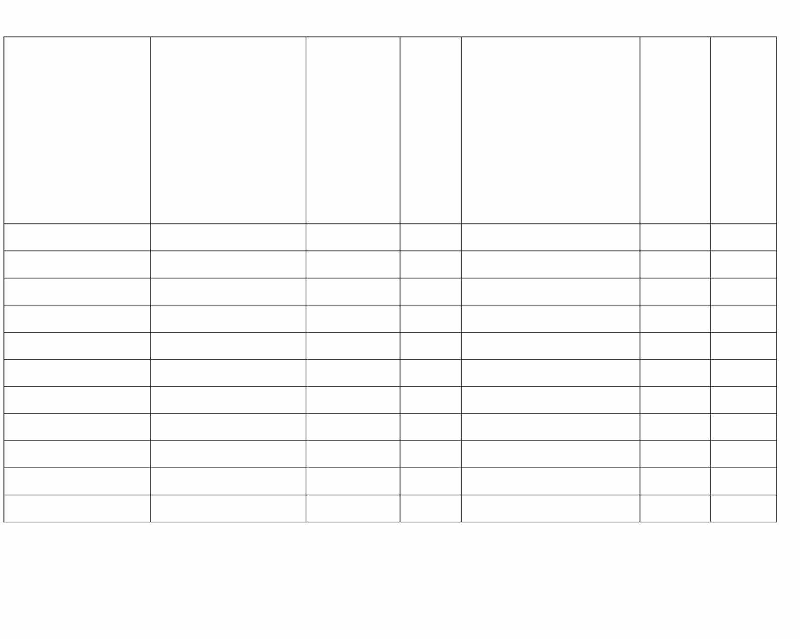
(3. Completing this form is voluntary, but failure to provide the information will prevent program participation..

Volunteer Service Agreement Group Sign-up Form
OF301b
Page 2 of 2 USDOI - USDA - USDOC - USDOD

