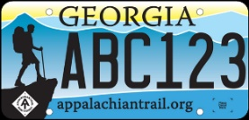 | Appalachian Trail License Plate Grant Program  Agency Endorsement Form | 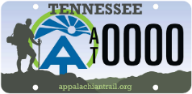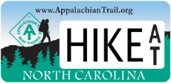

Instructions for Applicant
Please submit this form to the appropriate federal agency along with a draft of your application to inform them about the project. We encourage you to seek endorsement at least four weeks prior to the application deadline in order to provide agency representatives ample time to review your proposal.
Instructions for Federal Agency Representative
Please complete this form to indicate whether your agency approves of the grant project work proposed for the Appalachian Trail lands within your jurisdiction. Please indicate whether volunteer protection (e.g. VIF or VIP) or Special Use Permits are required to perform the proposed work on federal land. If yes, please indicate whether agreements are already in place, or if agreements are being processed (estimated approval date). If the applicant has made no attempt to secure necessary permits or volunteer protection agreements, please indicate this in your comments.

It is the responsibility of the applicant to meet all federal requirements for project work. When complete, please return this form to the grant applicant. If you have questions about the form, please contact the ATC Regional Office at soro@appalachiantrail.org.

Organization Applying for A.T. Grant:
Project Title or Description:
Project Location:
Agency Name and District:
Agency Contact Name:
Agency Contact Phone:
Agency Contact Email:
Does the agency endorse this project?
Volunteer Protection Agreement (VIF/VIP) required?
Approval date (or estimated approval date):
Special Use Permit required?
Approval date (or estimated approval date):
Comments:
Agency Representative Signature & Date: ___________________________________________

