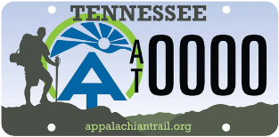 | Appalachian Trail License Plate Grant Program  A.T. Club Grant Project Endorsement Form | 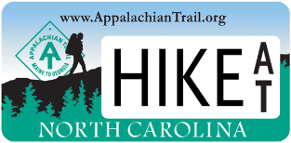

Instructions for Applicant
Please submit this form to the appropriate A.T. maintaining club along with a draft of your application to inform them about the project. We encourage you to seek endorsement at least four weeks prior to the application deadline to provide club representatives ample time to review your proposal.
Instructions for A.T. Club Representative
Please complete this form to indicate whether your A.T. maintaining club approves of the project work proposed for your section of the Appalachian Trail in the proposed A.T. License Plate Grant. When complete, please return this form to the grant applicant. If you have questions about the form, please direct them to the ATC Regional Office. soro@appalachiantrail.org.Thank you for your cooperation!

Organization Applying for A.T. Grant:
Project Title or Description:
Project Location:
A.T. Club Name:
A.T. Club Contact Name:
A.T. Club Contact Phone:
A.T. Club Contact Email:
Does the club endorse this project?
Comments:
Club President’s Signature & Date: _________________________________________________

